Conceptual Data Modeling - Diagram Report

**Alden**

Project Name: LawnCare Database Project

Description: To construct a database and application for interacting with it to serve the needs of a small lawn care company.

Index:

Conceptual Model: page 2

Entity: Owner: page 3

Entity: Property: page 3

Entity: Service: page 4

Entity: Workman: page 4

Entity: Equipment: page 5

Entity: WorkOrder: page 6

Entity: Repair: page 6

Entity: Timesheet: page 7

Conceptual Model:

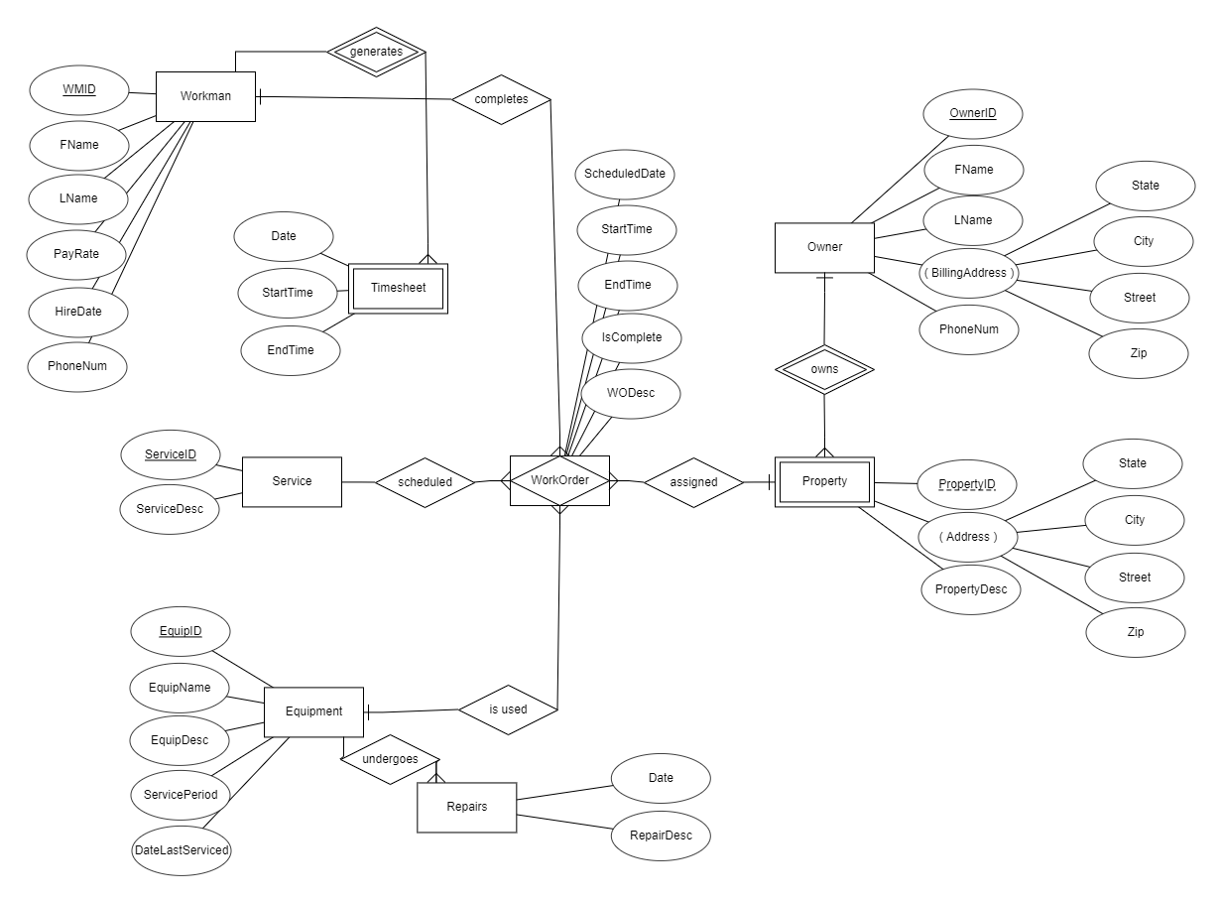

Entities:

Entity Name: Owner

Description: Stores an owners name and billing address as well as contact information.

Comments:

Purpose: An Owner registers properties with the company.

Attributes

|  |  |  |
| --- | --- | --- |
| **Name** | **Description** | **Keys** |
| OwnerID | Unique ID for Owner. Auto-generated. | PK |
| FName | First Name |  |
| LName | Last Name |  |
| BillingAddress | State City Street Zip Info |  |
| PhoneNum | Phone number to contact |  |

Relationship Name: owns

Description: An Owner owns many properties

Entity Name: Property

Description: Will store a property’s description and address.

Comments:

Purpose: Properties are what the company provides services for.

Attributes

|  |  |  |
| --- | --- | --- |
| **Name** | **Description** | **Keys** |
| PropertyID | Unique ID for Property. Auto-generated. | PK |
| Address | State City Street Zip Info. Multivalued. |  |
| PropertyDesc | Short Description to disambiguate property. |  |

Entity Name: Service

Description: Will be one of many types of service provided to be performed on a property. Will contain a description the service.

Comments:

Purpose: A Service is what the company provides for customers to be performed on their properties.

Attributes

|  |  |  |
| --- | --- | --- |
| **Name** | **Description** | **Keys** |
| ServiceID | Unique ID for service. Auto-generated. | PK |
| ServiceDesc | Short description of service. |  |

Relationship Name: is provided

Description: A Service is provided to properties.

Entity Name: Workman

Description: Stores employee information such as name and contact info, as well as hire date and payrate.

Comments:

Purpose: Employees will carry out the services the company provides.

Attributes

|  |  |  |
| --- | --- | --- |
| **Name** | **Description** | **Keys** |
| WMID | Unique ID for workman. Auto-generated. | PK |
| FName | First Name |  |
| LName | Last Name |  |
| PayRate | Workman’s hourly rate in cents |  |
| HireDate | Date employee was hired. |  |
| PhoneNum | Contact Number. Optional. |  |

Relationship Name: completes

Description: An Employee completes the workorder they are assigned.

Relationship Name: generates

Description: An Employee generates Timesheets as they complete workorders..

Entity Name: Equipment

Description: Stores information on equipment owned by the company. Contains description, as well as repair history and maintenance information.

Comments:

Purpose: Equipment is used to complete workorders.

Attributes

|  |  |  |
| --- | --- | --- |
| **Name** | **Description** | **Keys** |
| EquipID | Unique ID for Equipment. Auto-generated. |  |
| EquipName | Name of Equipment |  |
| EquipDesc | Short description of equipment. |  |
| ServicePeriod | Recommended max number of days between repairs |  |
| DateLastServiced | Date of Last Service. |  |

Relationship Name: is used in

Description: Equipment is used in work-orders to complete said work-order.

Relationship Name: undergoes

Description: Equipment undergoes repairs and generates repair logs.

Entity Name: WorkOrder

Description: References data from Workman, Service, Equipment, and Property to create a scheduled work task..

Comments:

Purpose: A WorkOrder is a billable item.

Attributes

|  |  |  |
| --- | --- | --- |
| **Name** | **Description** | **Keys** |
| ScheduledDate | Date Workorder is scheduled |  |
| StartTime | Beginning of Workorder’s execution |  |
| EndTime | End of Workorder’s execution |  |
| IsComplete | Status of Workorder. |  |
| WODesc | Short description for workorder. Optional. |  |

Relationship Name: is assigned

Description: A workorder is assigned to properties..

Entity Name: Repairs

Description: Will record repair and maintenance events for equipment owned by the company. Has a date and a description.

Comments:

Purpose: A WorkOrder is a billable item.

Attributes

|  |  |  |
| --- | --- | --- |
| **Name** | **Description** | **Keys** |
| Date | Date of repair log entry |  |
| RepairDesc | Short note describing repair/maintenance event |  |

Entity Name: Timesheet

Description: Created as employees complete work-orders. Records the time spent working and calculates wages earned.

Comments:

Purpose: timesheets are used to calculate employee wages.

Attributes

|  |  |  |
| --- | --- | --- |
| **Name** | **Description** | **Keys** |
| Date | Date that timesheet references |  |
| StartTime | Start of timeblock |  |
| EndTime | End of timeblock |  |